1.Draw a flow chart to print sum of 1 to 10 numbers.

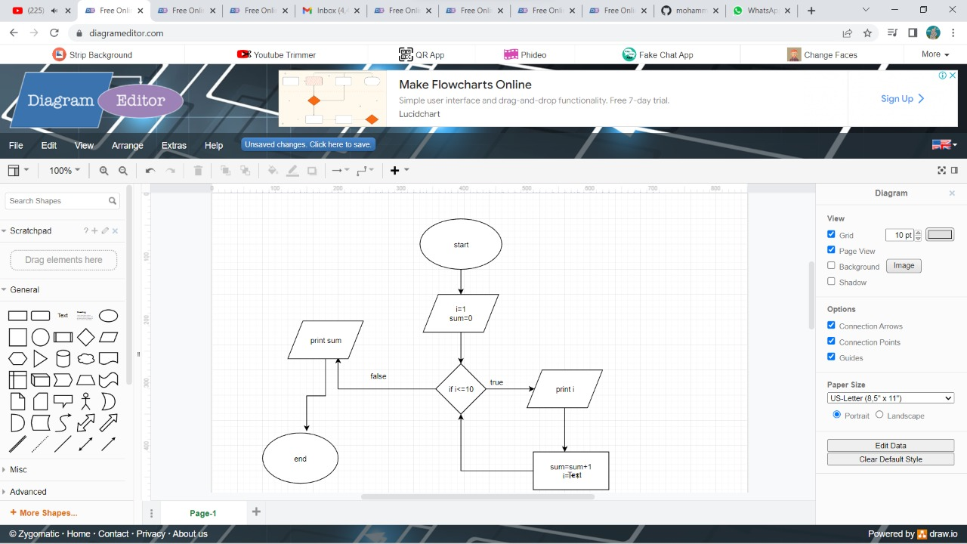

2.Draw a flow chart to print even number between 1-n

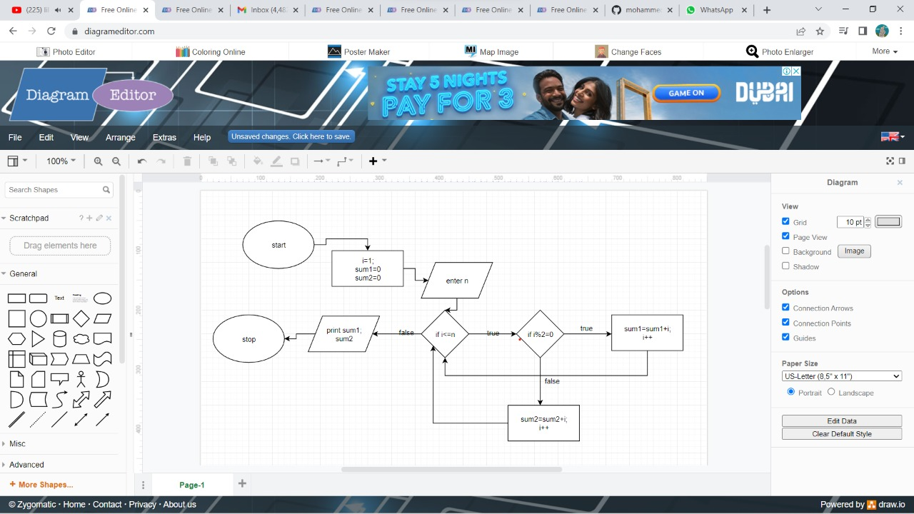

3.Draw a flow chart to print odd number between 1-n

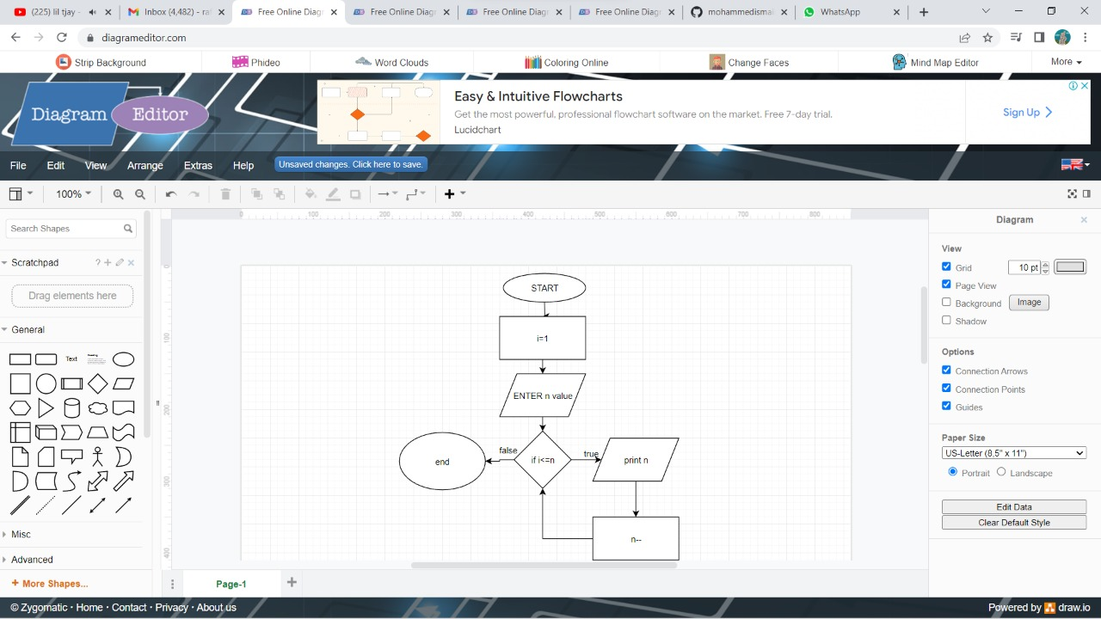

4.Draw a flow chart to print sum of even number between 1-n

5.Draw a flow chart to print sum of odd number between 1-n

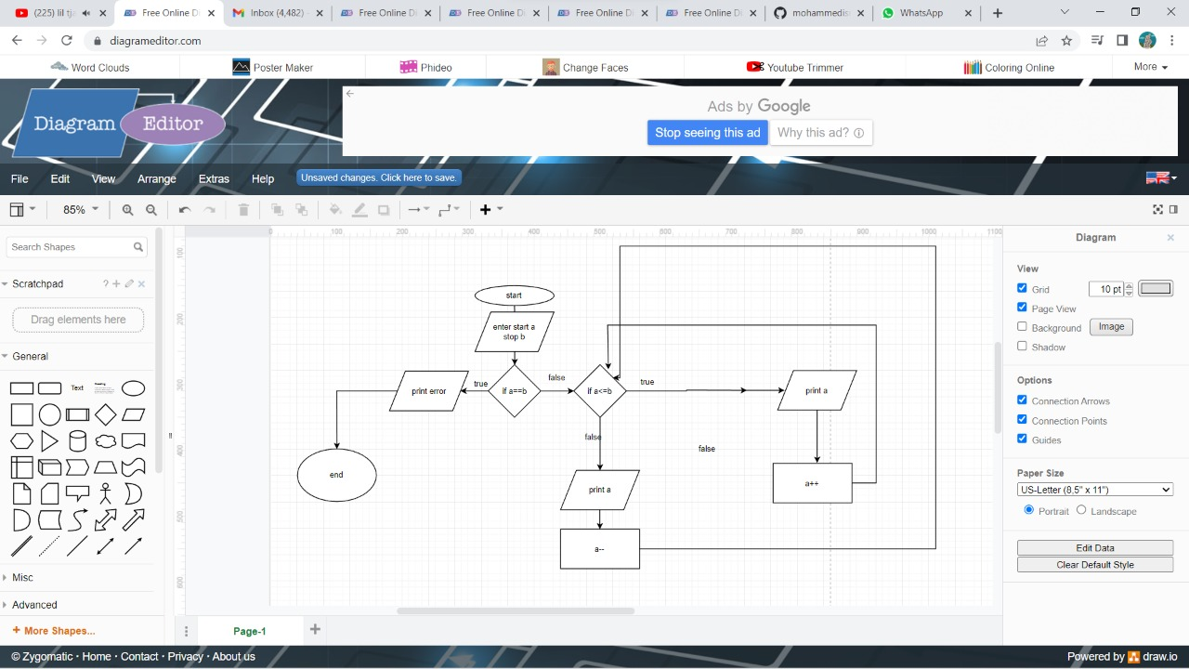

6.Draw a flow chart to print n-1

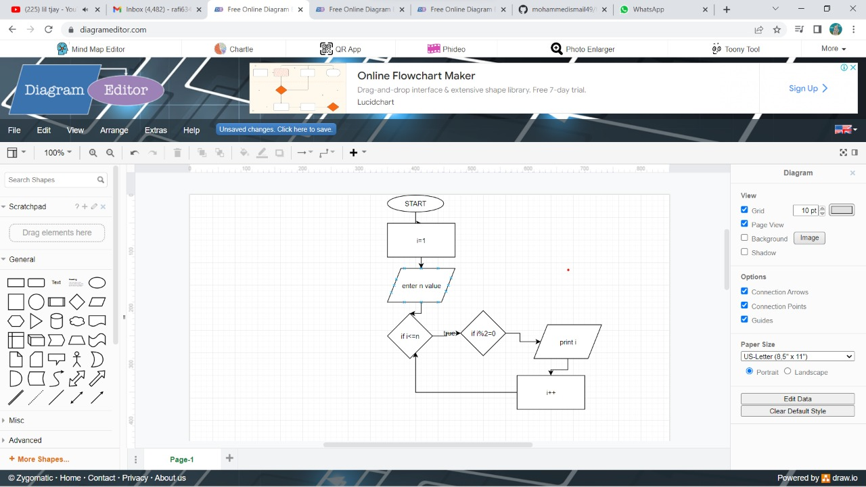

7.Draw a flow chart to print two accept two numbers and print between numbers

